 | SIMATS ENGINEERING | 
 | Saveetha Institute of Medical and
 | Technical Sciences
 | Chennai- 602105

Student Name: MONISH L Course Code: CSA0804
Reg. No. : 1972260035
Slot: B

Course Name: Python Programming
Course Faculty: Dr. Rohith Bhat C
Project Title: Data Cleaning and CSV Analysis Pipeline — Module 3: Data Cleaning
Module Photographs: (2 photographs – team photo and module implementation)
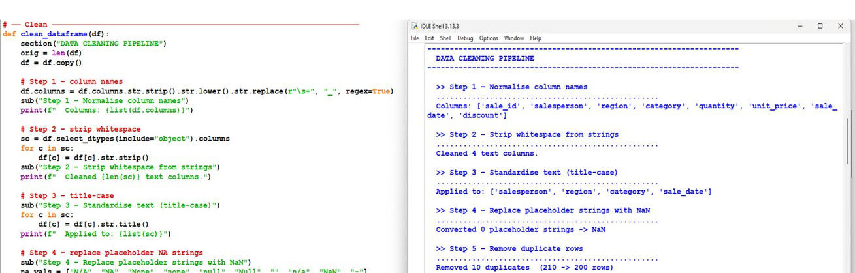 | 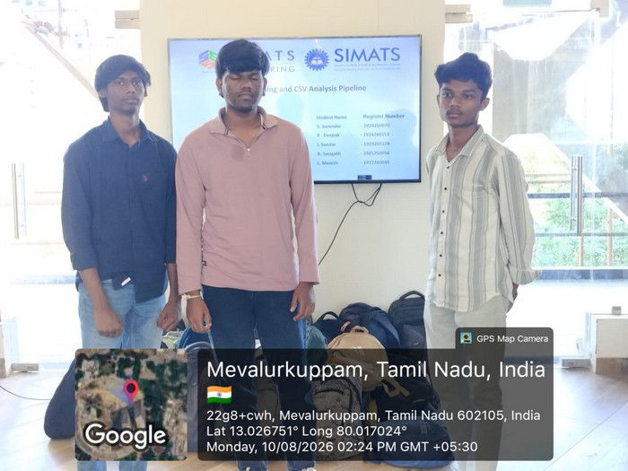
Project Description: (Module 3 contribution, including model description)
Module 3 – Data Cleaning is the core technical module of the pipeline, implemented in Python using pandas, and directly addresses every issue flagged during the Module 2 data-quality assessment (missing values, duplicates, formatting inconsistencies and outliers). My contribution centred on a single reusable clean_dataframe() function, favouring reusable transformation steps over one-off notebook fixes so the same logic can run on new, unseen CSVs.
The pipeline runs as a sequence of logged steps: normalising column names (stripping, lower-casing and replacing whitespace with underscores), stripping whitespace from text columns, standardising text columns to title-case, and replacing placeholder strings ("N/A", "NA", "None", "null", "n/a", "-", etc.) with proper NaN values so pandas can recognise them as missing. Each step prints a short before/after summary — e.g., how many text columns were cleaned or how many placeholder strings were converted — to keep the transformation auditable.
Beyond text normalisation, the function removes duplicate rows (a sample run cut 210 rows to 200, removing 10 duplicates), coerces key columns to their correct numeric dtypes, and parses date columns — flagging values that fail to parse as NaT rather than silently dropping them. Every cleaning decision (impute vs. drop, cap vs. remove an outlier) is justified in comments rather than applied blindly, and the cleaned output is written to a separate file from the raw data so the original source is always preserved.
Testing was carried out by running the function against the raw dataset in an interactive shell and verifying the printed step-by-step log against the Module 2 quality report. Known limitations include cleaning rules (e.g., placeholder lists, outlier handling) that are tailored to this dataset and may not generalise to structurally different data, and the fully in-memory, pandas-based approach, which would need to be replaced by tools like Dask or PySpark for datasets too large to fit in RAM.
Student Signature Guide Signature


